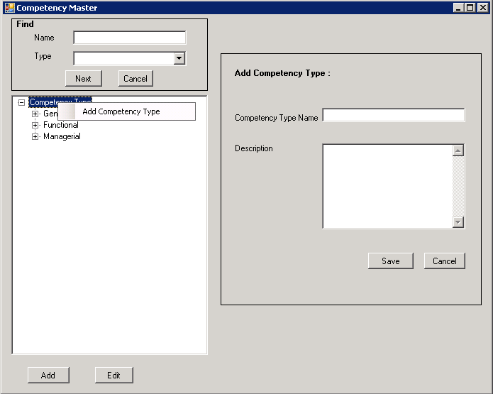
Functionality:
The screen shall be used to add, edit,delete and rename competency type and competency, search option also provided to carry out the given functionalities.
Add Competency Type
Using Context Menu:
- User shall select the highest node “Competency Type”.
- Right click on the node shall display a context menu.
- User shall select “Add Competency Type”.
- Enter the competency type name and description and click on “Save”.
Without using context menu:
- User shall select the highest node “Competency Type”.
- Click on “Add”.
- Enter the competency type name and description and click on “Save”.

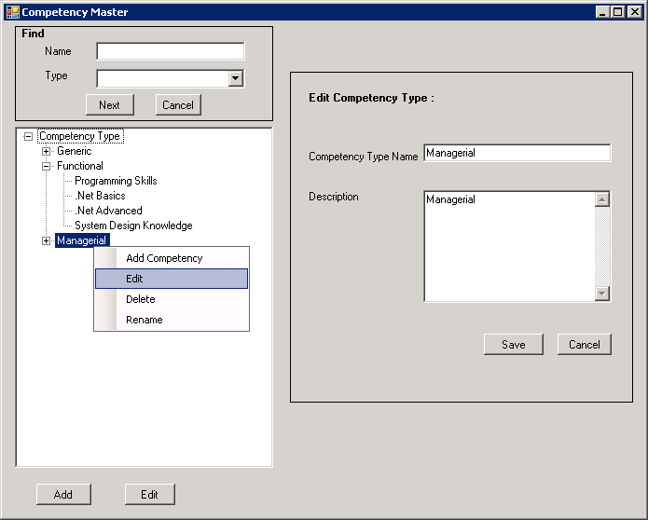
Edit Competency Type
- User shall select a node(competency type).
- Right click on the node shall display a context menu and click on “Edit” option or click Edit button..
- Edit values for name and description and click “Save”..
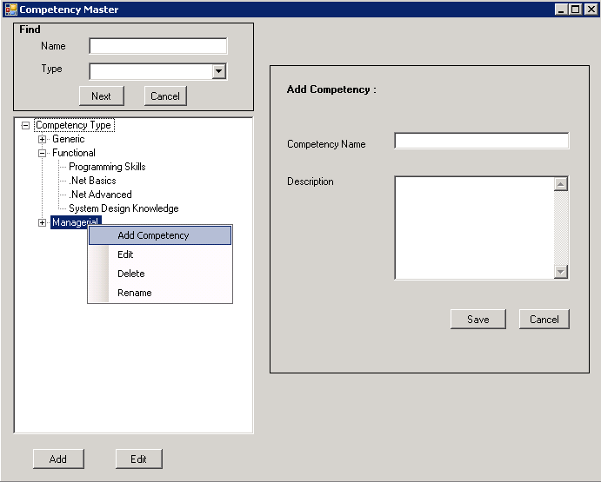
Add Competency
Using Context Menu:
- User shall select a node(competency type).
- Right click on the node shall display a context menu.
- User shall select “Add Competency ”.
- Enter the competency name and description and click on “Save”.
Without using context menu:
- User shall select a node(competency type).
- Click on “Add”.
- Enter the competency name and description and click on “Save”.

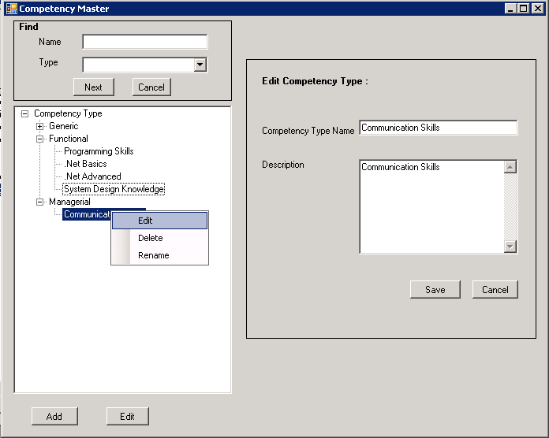

Edit Competency Type
- User shall select a node(competency).
- Right click on the node shall display a context menu and click on “Edit” option or click Edit button..
- Edit values for name and description and click “Save”.
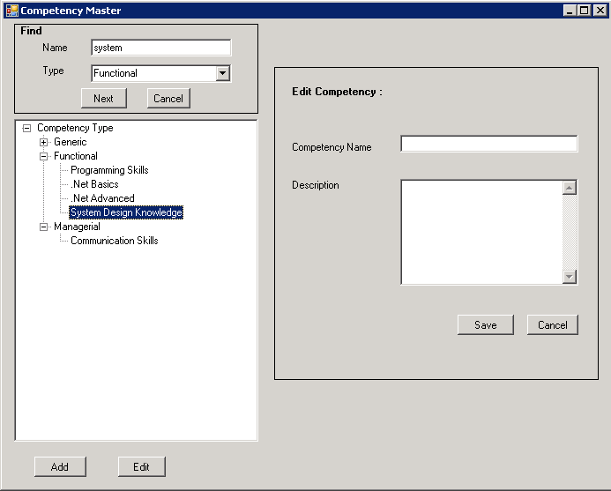

Search Competency.
- Enter the competency name on the “Find” panel and select the competency type from the given list.
- Click on “Next”.
- The matching competency gets selected.
- Competencies of similar names will get highlighted as user keeps clicking “Next”.

Validations:

- Root of the hierarchy has to be single.
- Node having child nodes can't be deleted.
- No two nodes can have same name in the hierarchy.

Tables affected:
- CompetencyDescriptionDetail
- CompetencyMaster
- CompetencyTypeMaster

